News App

Home Page:

Login Page:

Register Page:

profile:

All Articles:

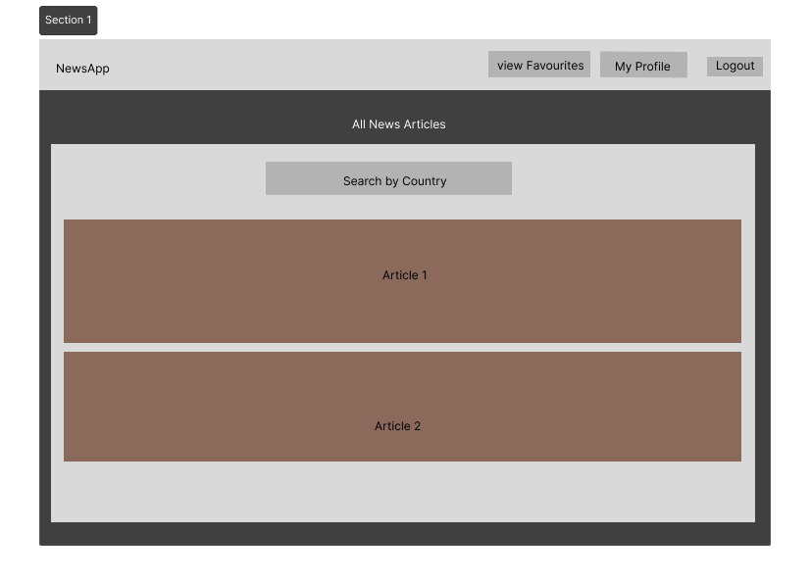

Favourite Articles:

